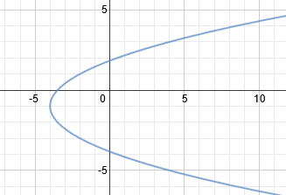Module 2 – Linear Functions and Their Graphs

Lesson 2 – Functions and Relations

Homework 1

Name

Answer each section.

Fill in the blanks

1. A _________________________ is a pairing between two variables in ordered pairs (x, y).
2. The set of all second-coordinates or y-values of a relation is called the _________________________.
3. The _________________________ is the set of all first-coordinates or x-values of a relation.
4. A relation in which each value of the domain corresponds to exactly one value of the range is called a _________________________.

Determine whether the following relations are a function or not.

1. { (2, 3), (1, 2), (0, 4), (4, 6), (0, 3) }

|  |  |  |  |  |  |
| --- | --- | --- | --- | --- | --- |
| x | 11 | 12 | -10 | -9 | -8 |
| y | 4 | 5 | 6 | 7 | 8 |



|  |  |  |  |  |  |
| --- | --- | --- | --- | --- | --- |
| x | -6 | -5 | -4 | -3 | -2 |
| y | 5 | 5 | 5 | 5 | 5 |

1. { (0, 5), (4, 4), (2, 5), (3, 5), (1, 6)}